**Meno:_________________________________________**

hept-2-én penta-2,3-dién

cyklopentín 2,4-dimetylhex-1-én

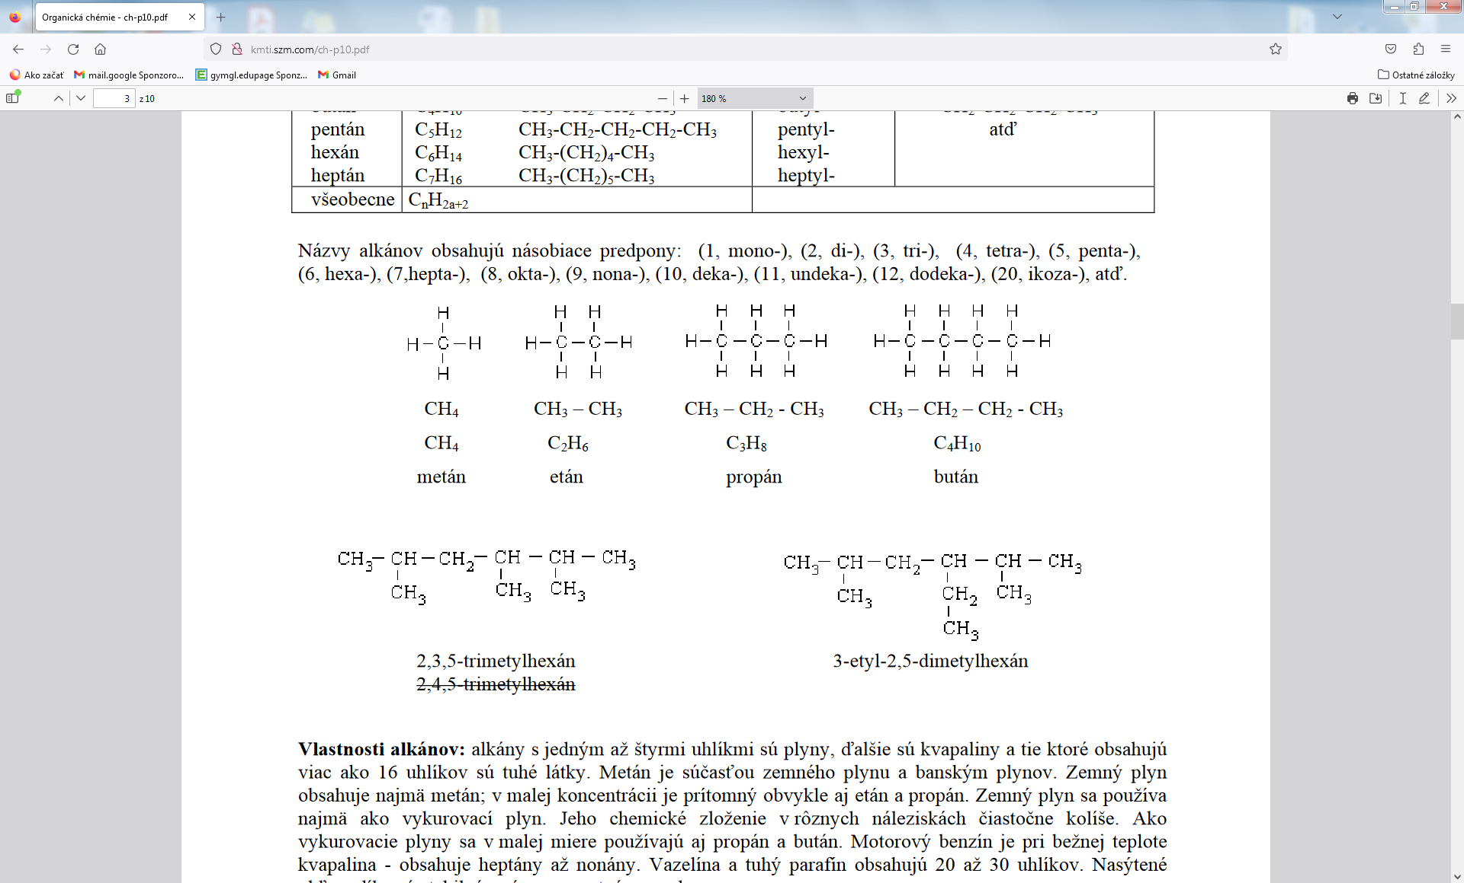

_______________________________________ _________________________________________________

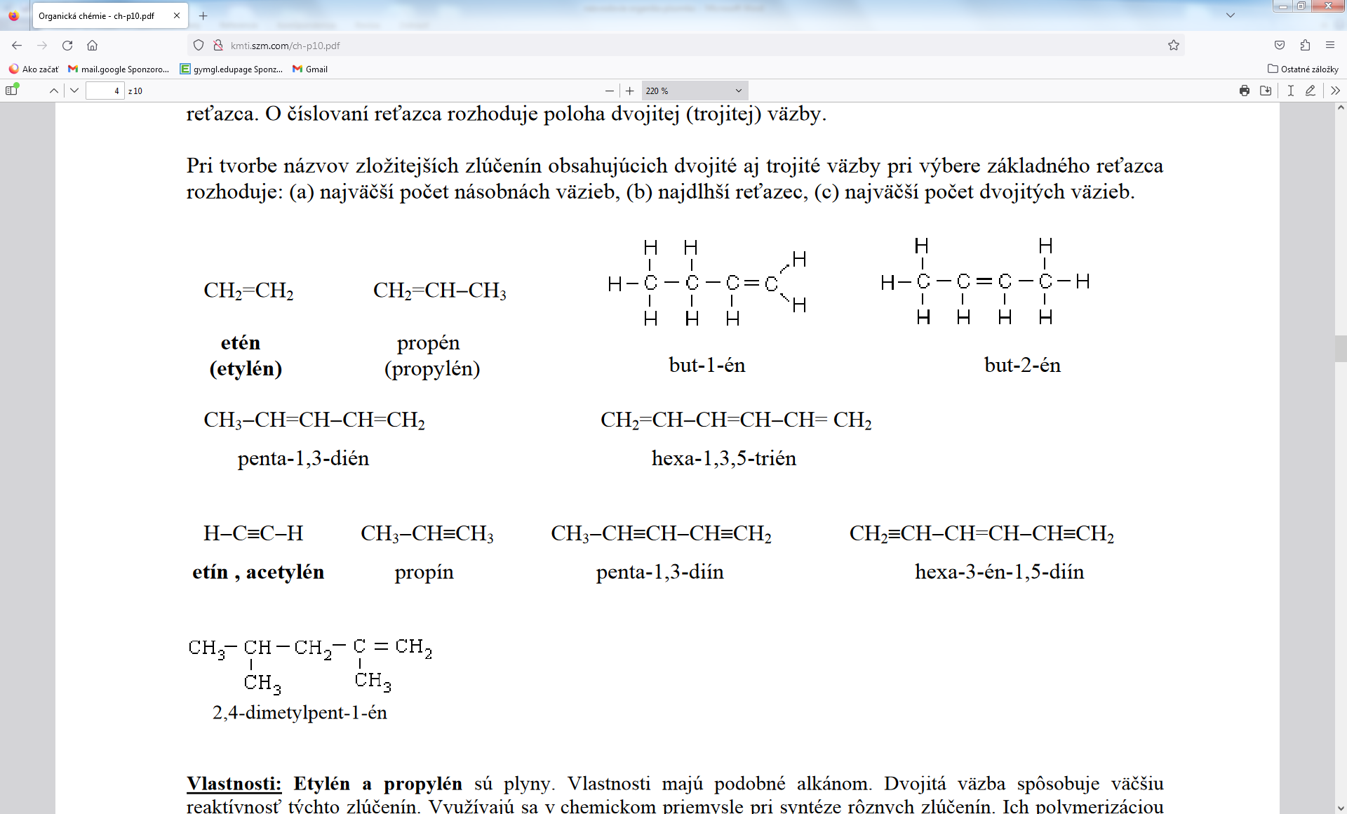 

___________________________________________________ ______________________________________



______________________________________ _________________________________________________

but-2-ín hexa-1,3,5-trién

**Meno:_________________________________________**

hept-2-én penta-2,3-dién

cyklopentín 2,4-dimetylhex-1-én



_______________________________________ _________________________________________________

 

___________________________________________________ ______________________________________



______________________________________ _________________________________________________

but-2-ín hexa-1,3,5-trién